

|  |  |
| --- | --- |
|  | **AMERICAN INTERNATIONAL UNIVERSITY-BANGLADESH (AIUB)**  **Faculty of Science and Technology Department of Computer Science and Engineering** |

|  |
| --- |
| **MID TERM REPORT** |
| **SECTION: C** |

**Advance Database Management System**



**Semester: Spring 2022-2023**

**Date of Submission:**

**Submitted to:**

**REZWAN AHMED**

**Computer Science Department of CSE**























**Project Name: Air-Ticket Online Booking System**



|  |  |  |  |
| --- | --- | --- | --- |
| **Serial no** | **Student’s Name** | **ID** | **Dept.** |
| 1 | NUSHRAT JAHAN | 20-42192-1 | CSE |
| 2 | SINTHIA MALIHA MUMU | 20-42242-1 | CSE |
| 3 | SADIA ISLAM KATHI | 20-42319-1 | CSE |

**Table of Contents**

Introduction 3

System Summary 3

ERD Diagram 3

Class Diagram 4

Use Case Diagram 4-5

Activity Diagram 5

Schema Diagram 6

Screenshots of Sample Data 7-9

Query Writing 10

User Interface for Login and Registration 11

# Introduction:

Our Air-Ticket Online Booking System is an implementation of a general Air-Ticketing application, which helps the customers to book the available air tickets. This system also covers various features like login of the customers, managing the functionalities of the application by the manager, customers can choose their ticket types and do online payment. Since 2020 pandemic situation staying safe is the big issue for us. So, we designed our system user friendly so that customer can easily book the tickets and receive the tickets from online through the email. That’s why online booking of air tickets is mostly needed.

# System Summary:

Many countries have forged ahead advancement of modern technologies. To achieve this in our country, technological collaborations are needed. Our proposed system makes sure that the customer has complete freedom, where the customers can log in to this system and can book their tickets by themselves. In our proposed system only, the registered users can book the tickets, view timing, availability of tickets and cancel their tickets. In this proposal, the entire work is done online and tickets with ID is also provided for passengers as a printed document.

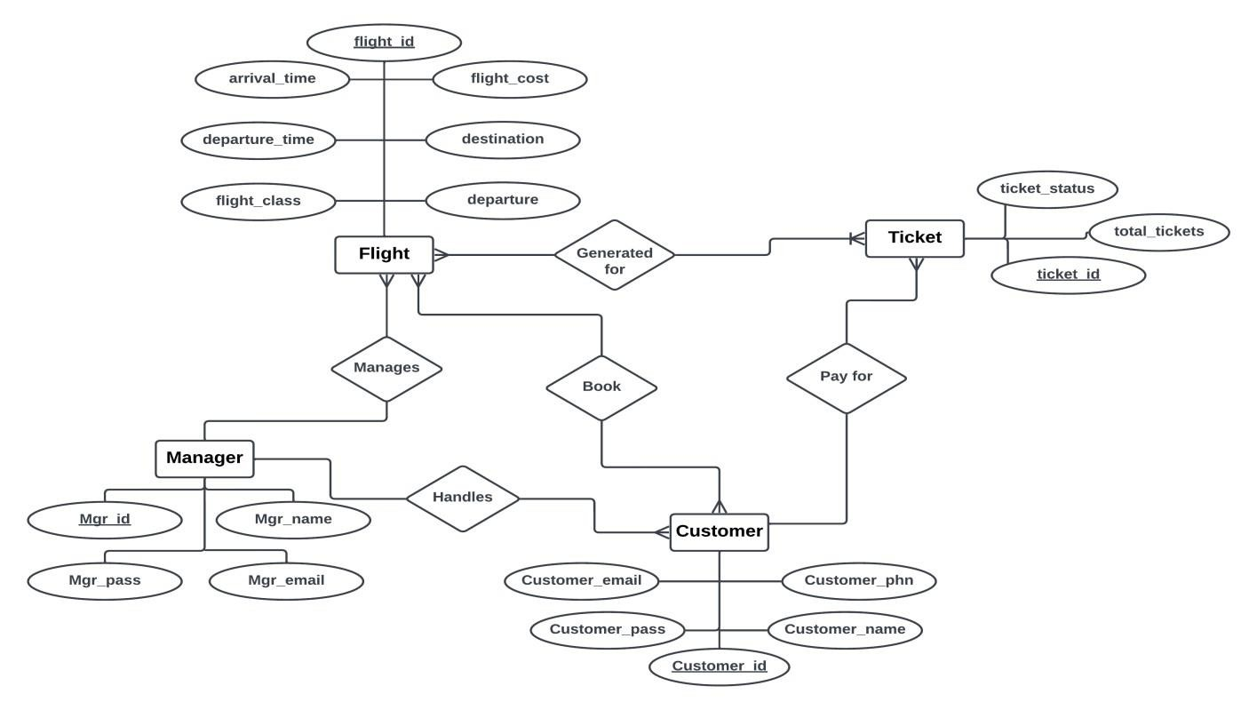

# ERD Diagram:

**Scenario Description:** In an Air-ticket online booking system, a manager may handle many customers. The system stores customer name, id, mobile number, password, and e-mail. A customer is identified by a customer id. In this system, it stores manager name, id, password, and email. A manager is identified by manager id. One manager can manage by many flights. The system also stores flight id, arrival time, departure time, destination, cost, departure, and class. A flight is identified by a flight id. Many flights are generated by many tickets. The system stores ticket id, status, and total tickets. Many customers check many flights. One customer pays for many tickets.

# Class Diagram:

Customers can register to the system by providing their name, mobile no, address, and email. Anyone can see the flight list provided by the system. But to book the tickets one must log into the system. The system has the details of the flights. So, flight is a part of the system. A flight has its departure time and flight list is also included. Customers can book one or many tickets. Ticket type and seat no. must be chosen before confirming. Airport Manager must register himself by providing his name, email, and his id. He checks the system for verifying the payment method.

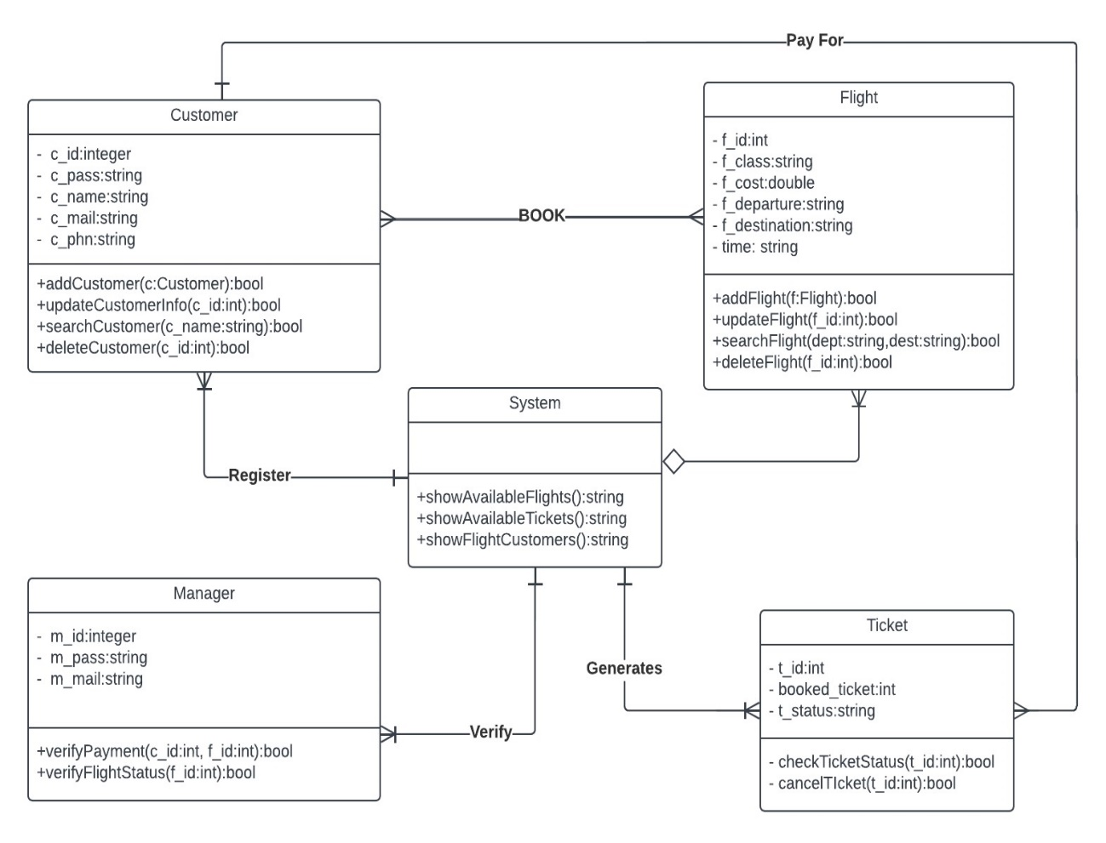

# Use Case Diagram:

Use case diagram consists of use cases and actors and shows the interaction between them. The main purpose is to show the interaction between the use cases and the actor. To represent the system requirement from user’s perspective. The use cases are the functions that are to be performed in the module. An actor could be the end-user of the system or an external system.

In our air-ticket online booking system, the customer will first register into the system for buying air tickets. They need to login into the system for getting access of the system. After that customer can check the availability of tickets from the system. If they want to buy tickets, they must choose the type of ticket. After choosing type, they must select seats. They have to pay for the tickets at the time they confirm their tickets, or they can cancel it too. They can pay by digital payment (bKash, Nagad & Rocket) or credit card. Manager can verify the payment method. After successfully confirming their payment, they will receive their ticket from the system. On the other hand, air-ticket manager also needs to register before login into the system. The manager needs to login into the system so that he can monitor the feedback forms and answer customer queries. Both customers and manager can update their information.

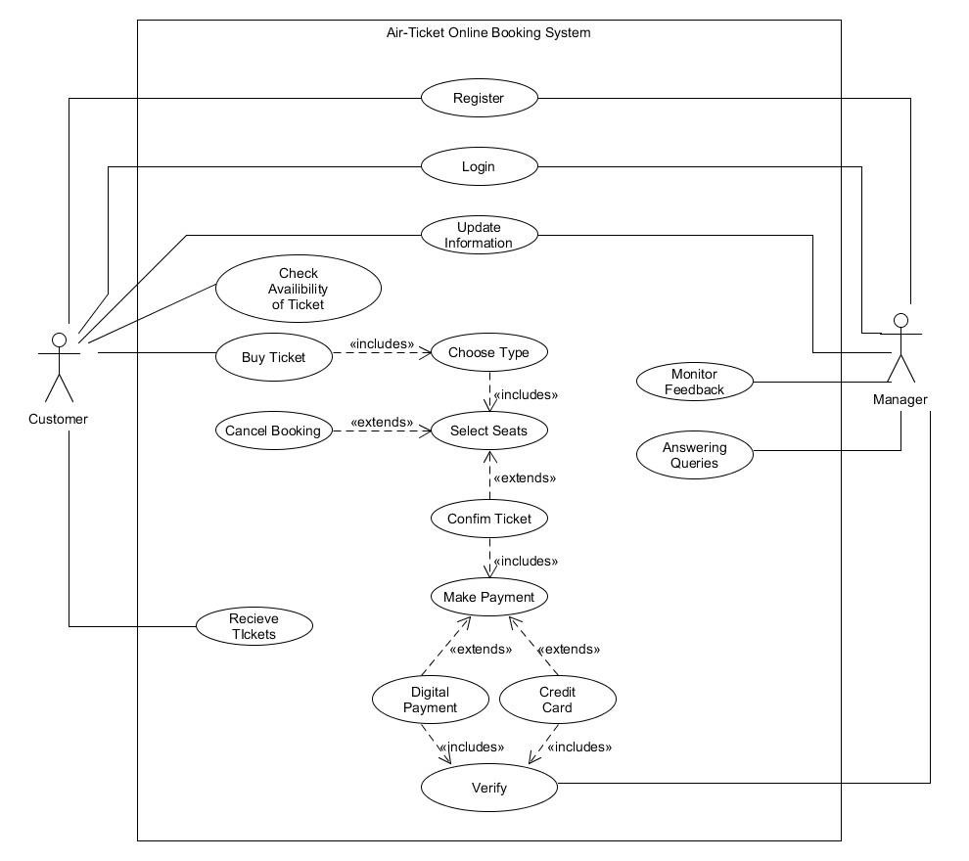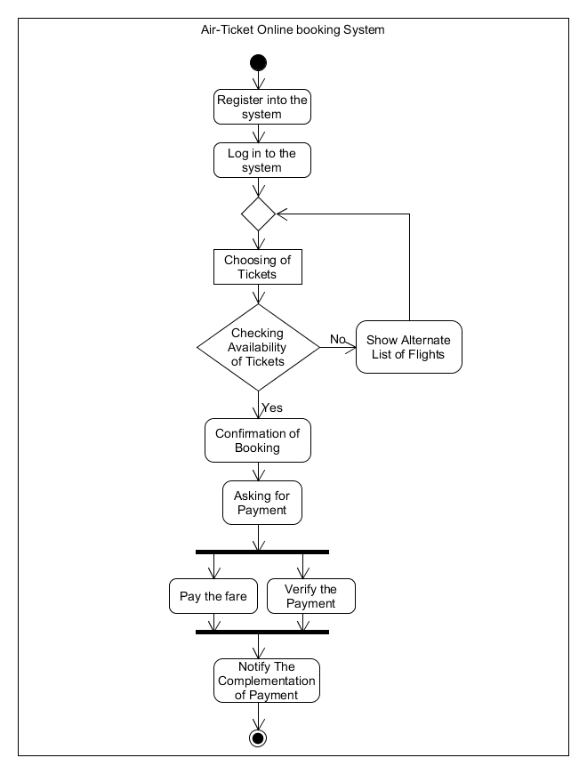

# Activity Diagram:

In our Air-Ticket Online Booking System at first a customer registers himself/ herself to the system. After that he/she can log in to the system. Then they can choose the ticket type of their chosen flight and also the seats. If tickets are available, then they can proceed to confirm the booking. When a customer confirms the booking, the system asks for the payment. While a customer pays the fare of the tickets, the manager also verifies the payment. After verifying, the system notifies the customer about the complementation of the payment.

# Schema Diagram:

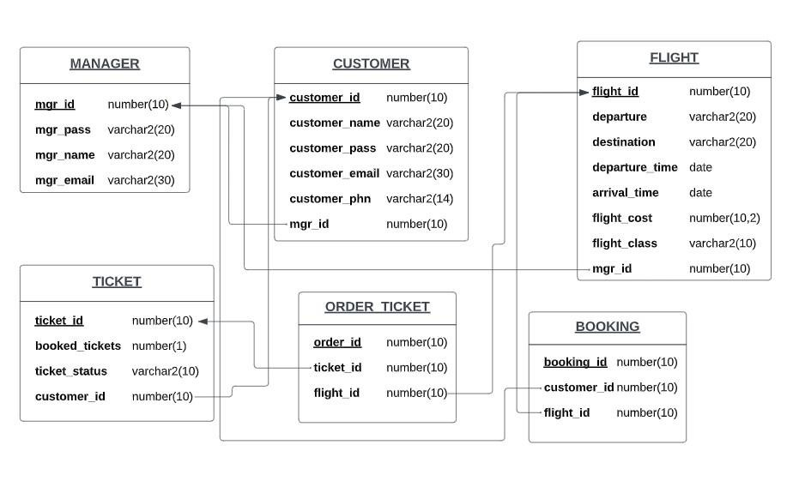

**Screenshots of Sample Data:**

MANGER TABLE:

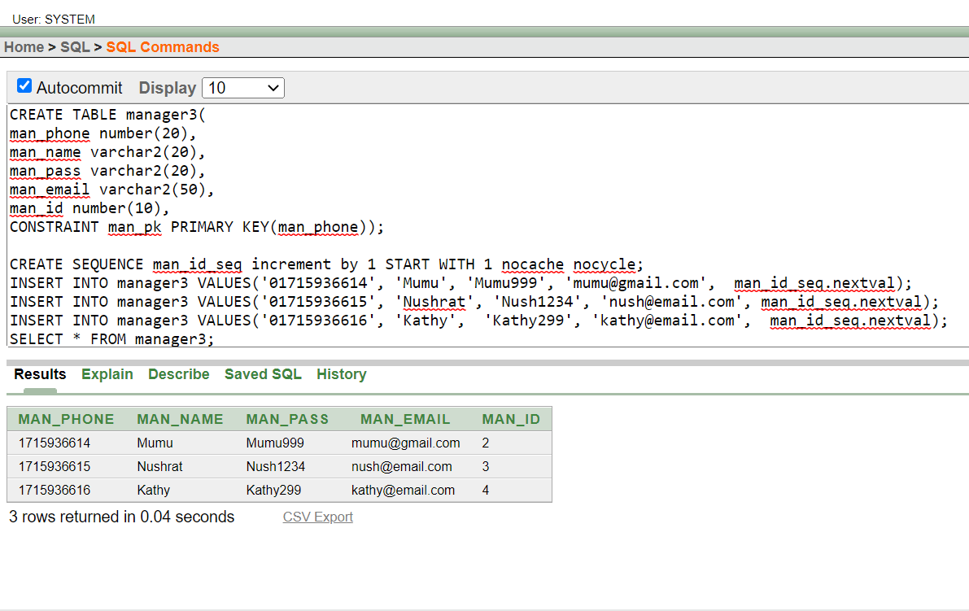

CUSTOMER TABLE:

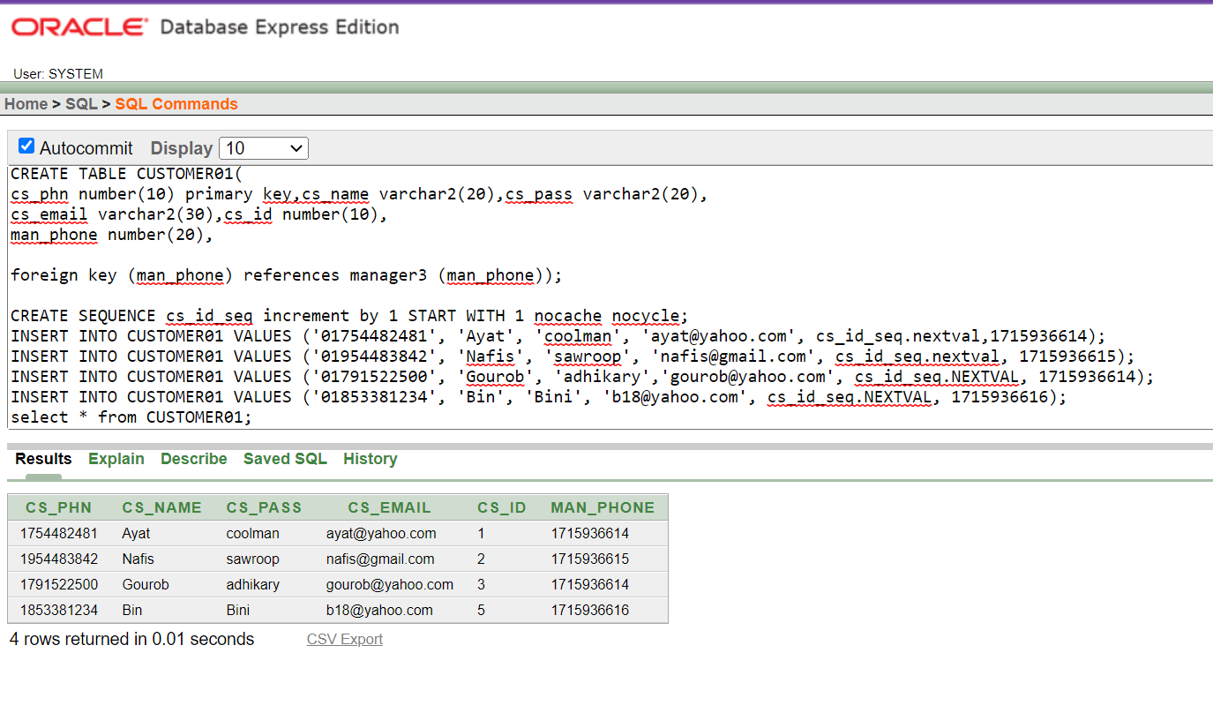

FLIGHT TABLE:

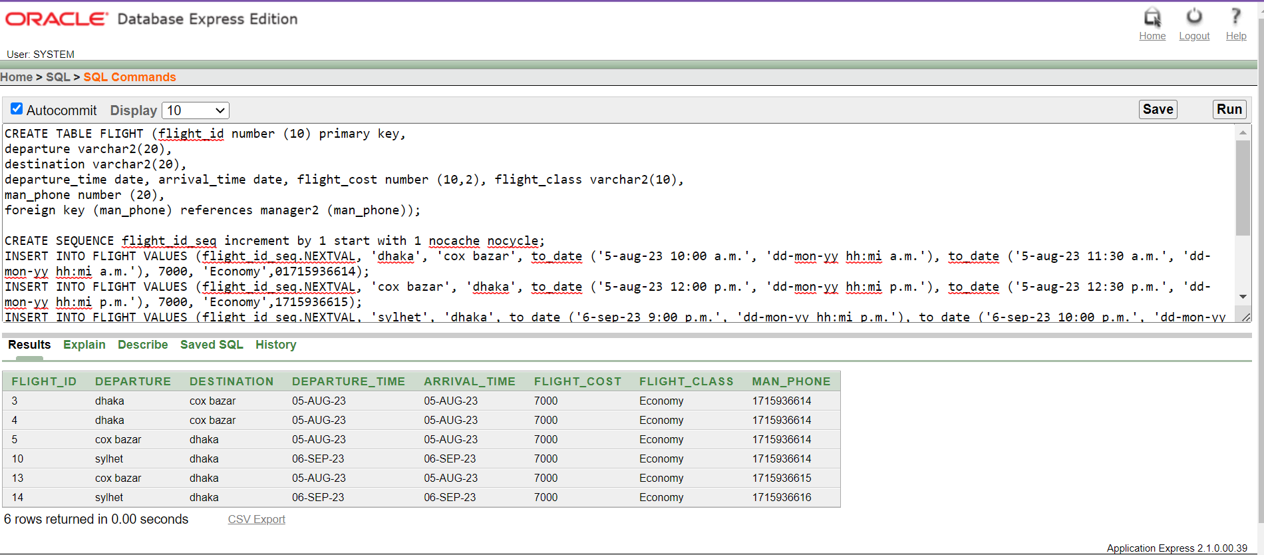

BOOKING TABLE:

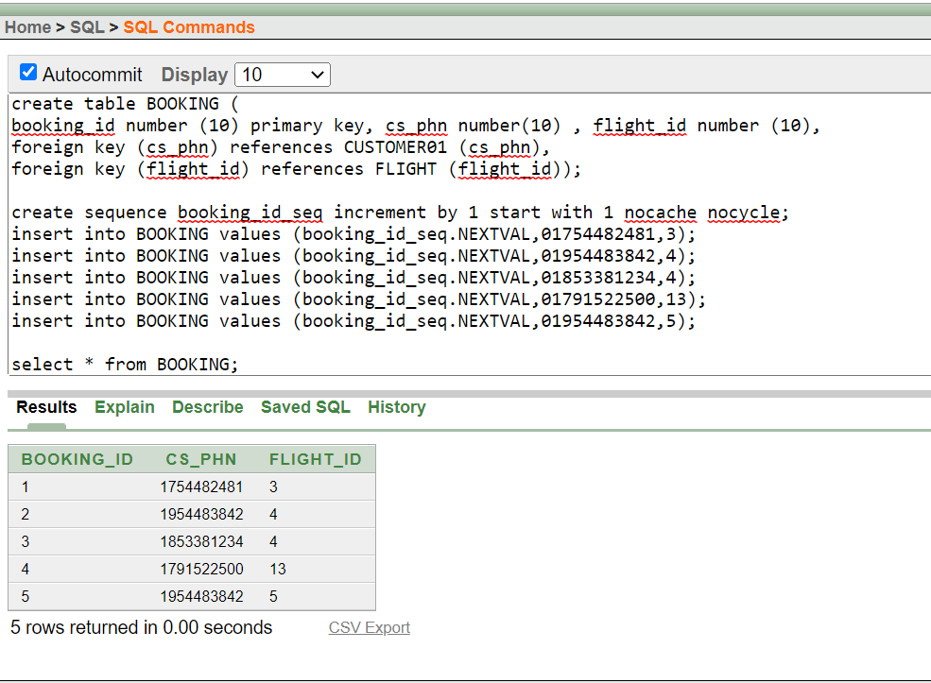

TICKETS TABLE:

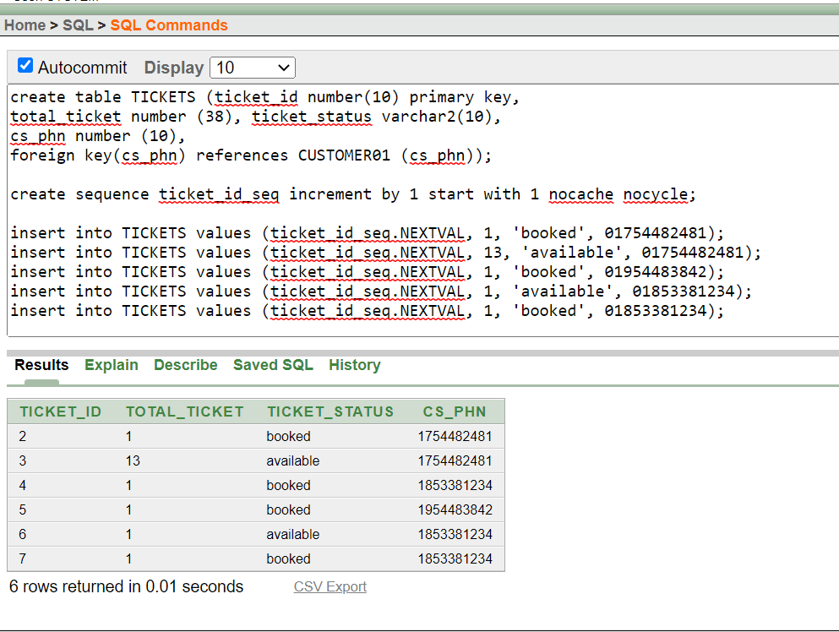

ORDER TABLE:

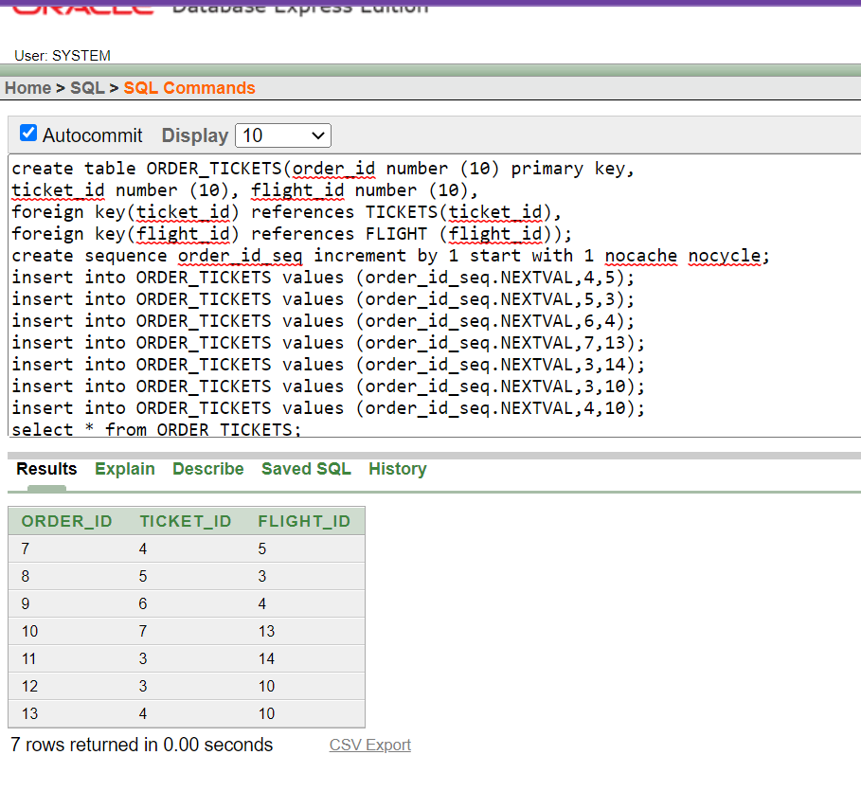

# Query Writing:

## Question:

1. Find customer name, flight cost, total tickets of a customer which was approved by man_phone last digit 15.
2. Find the available flights with lowest price.
3. Find the flight cost of an economy class with destination to cox bazar.
4. Find the flight wise total booked tickets.
5. Find the name of the customer who booked the maximum number of flights.
6. Find customer name and departure time of a flight with destination to dhaka.
7. Find the destination of lowest cost business class flight from departure dhaka.
8. Find the manager’s name who approved maximum flights.
9. Find all the customers who booked flight.
10. Find all flight details with maximum booked tickets.

### Answer:

1. select c.cs_name, f.flight_cost, t.total_ticket from CUSTOMER01 c, flight f, tickets t, order_tickets ot, booking b where c.cs_id=b.cs_phn and b.flight_id=f.flight_id and t.ticket_id=ot.ticket_id and ot.flight_id=f.flight_id and f.man_phone=1715936615;
2. select * from flight where flight_cost=(select min(flight_cost) from flight);
3. select flight_cost from flight where flight_class='Economy' and destination='cox bazar';
4. select f.flight_id, sum(t.total_ticket) from flight f, tickets t, order_tickets ot where t.ticket_id=ot.ticket_id and ot.flight_id=f.flight_id group by f.flight_id;
5. select cs_name from customer01 where cs_id in (select c.cs_id from customer01 c, flight f, booking b where c.cs_id=b.cs_id and b.flight_id=f.flight_id group by c.cs_id having count(c.cs_id) in (select max(count(c.cs_id)) from customer01 c, flight f, booking b where c.cs_id=b.cs_id and b.flight_id=f.flight_id group by c.cs_id));
6. select c.cs_name, f.departure_time from customer01 c, flight f, booking b where c.cs_id=b.cs_id and b.flight_id=f.flight_id and destination='cox bazar';
7. select destination from flight where flight_class='Economy' and flight_cost in (select min(flight_cost) from flight);
8. select man_name from manager3 where man_id in (select m.man_id from manager3 m, flight f where m.man_id=f.man_id group by m.man_id having count(m.man_id) in (select max(count(m.man_id)) from manager3 m, flight f where m.man_id=f.man_id group by m.man_id));
9. select c.cs_name, c.cs_email from customer01 c, tickets t where c.cs_id=t.cs_id and ticket_status='booked';
10. select * from flight where flight_id in (select f.flight_id from flight f, tickets t, order_ticket ot where t.ticket_id=ot.ticket_id and ot.flight_id=f.flight_id and ticket_status='booked'group by f.flight_id having sum(t.total_ticket) in (select max(sum(t.total_ticket)) from flight f, tickets t, order_ticket ot where t.ticket_id=ot.ticket_id and ot.flight_id=f.flight_id and ticket_status='booked' group by f.flight_id));

# User Interface for Login and Registration:

# COVER:

**REGISTRATION:**

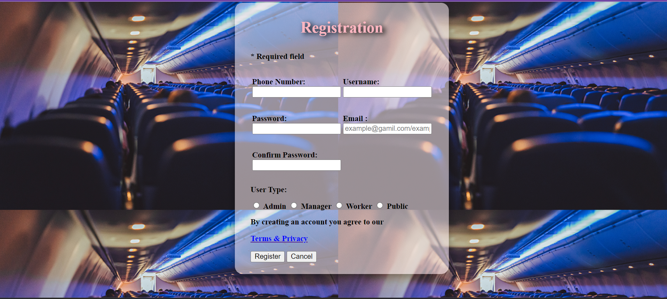

LOGIN:

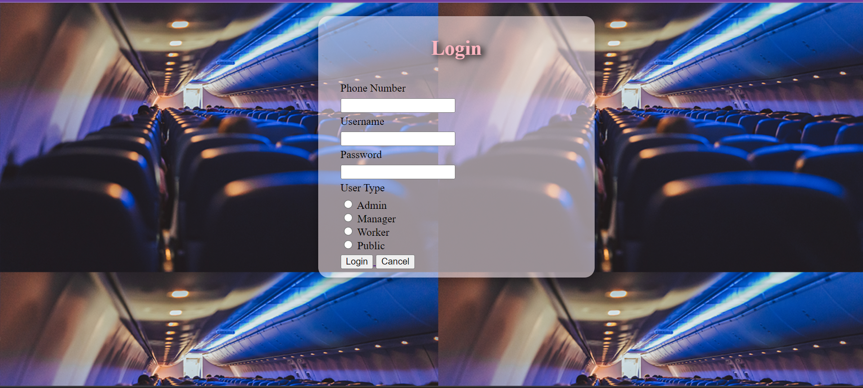

HOME PAGE:

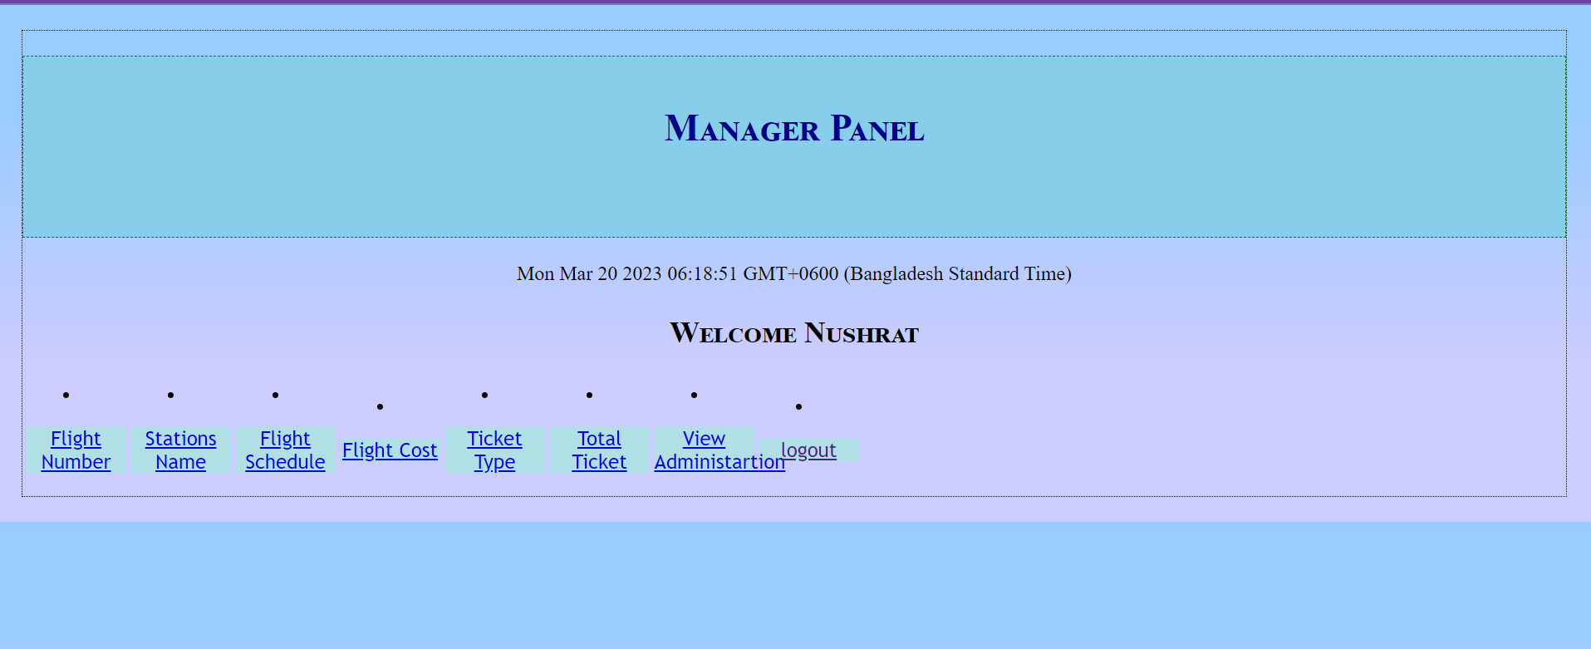

TICKET FORM:

